UNITED CHURCH OF CHRIST IN THE PHILIPPINES
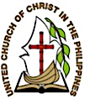

COUNCIL OF BISHOPS
877 EDSA, West Triangle, Quezon City

______________________________________________________
NO TO FOREIGN INTRUSION!
Statement of the Council of Bishops in Commemoration of the 123rd Philippine Independence Day, June 12, 2021

Everyone will sit under their own vine
and under their own fig tree,
and no one will make them afraid,
for the Lord Almighty has spoken. (Micah 4:4)

Our dearly loved country continues to face threats not only from China’s moves in the West Philippine Sea, but also from our unwillingness and inability to assert our sovereignty. China undermines our rights to national territory despite the July 12, 2016 The Hague arbitral ruling in favor of the Philippines, pointing out that China has no legal basis to claim historic rights to resources within the sea areas falling within their claimed nine-dash line.

What is more disturbing is President Rodrigo Duterte's position on the matter. In fact, CNN in one of its releases published on May 30, 2021, reproved Duterte's remark in his May 6 national address saying the Philippines’ arbitral win against China was just "a mere piece of paper that can be thrown away in a trash bin." Coming as it is from the highest official of our land, who is supposed to craft the country’s foreign policy, this is tantamount to a sell-out.

This and other government foreign policies like that of the reinstatement of the Visiting Forces Agreement with the United States and neoliberal policies clearly curtail our freedom to assert the interests and welfare of the Filipino majority over and against the dictates of foreign nations, and the undermining of our quest to develop a nationalist and democratic Filipino nation.

Even our retired generals are calling for a unified position on the West Philippine Sea. Former AFP Chief of Staff and Senator Rodolfo Biazon said: “First, we must have only one position even as we continue to defend our interest in the West Philippine Sea. We must not have differing stands, and that’s what we’re hearing now, and we would all be confused and that would weaken us.”

Meanwhile, retired general Eliso Rio, said that as we celebrate our Independence Day, “let us remember how we, Filipinos, more than a century ago, stood up to challenge a much stronger power in order to be freed from subjugation and bullying. Today, we face a real threat to our national security. China’s transgression of Philippine sovereignty and sovereign rights in the West Philippine Sea in violation of international law jeopardizes our future” (as reported in the Phil. Star).

In light of the foregoing, we reiterate UCCP’s previous statements concerning foreign intervention in Philippine affairs:

- We affirm the sovereignty of the Filipino people and their right to self-determination, free from any external interference, be it from the United States of America, or at this time, China.

- We call upon the Filipino people to stand vigilant in resisting foreign domination and control of our nation. We call on them to organize against laws, decrees, treaties and trade organizations that legitimize the interests of foreign nations over and above the interests of the Filipino majority.

We call upon our churches and all Filipinos to speak out to assert our sovereignty, saying, “NO TO FOREIGN INTRUSION!” Feasible actions to take may include conducting massive educational programs in our local churches and communities pertaining sovereignty in light of Christian faith and God’s emancipating words. This may be coupled with active participation with civic and religious groups’ advocacy works to denounce all forms of foreign intrusion in the affairs of our country.

These days, even our very own fisherfolks are afraid to fish in our own territory due to Chinese military’s prohibitions. We long for the day as envisioned by the prophet Micah, when we will experience as a country and a people: to be secured and unafraid, and enjoying God-given resources of the land. +++

THE COUNCIL OF BISHOPS
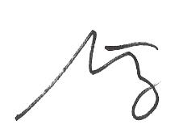
12 June 2021

Bishop Melzar D. Labuntog
General Secretary
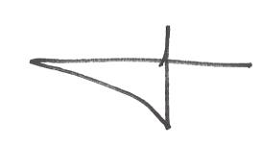  Bishop Joseph G. Agpaoa  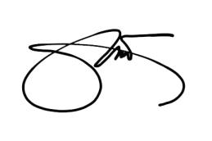  North Luzon Jurisdictional Area | 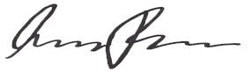  Bishop Emergencio D. Padillo  Middle Luzon Jurisdictional Area
Bishop Joel E. Tendero  South Luzon Jurisdictional Area | 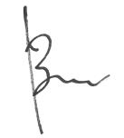  Bishop Jerome C. Baris  East Visayas Jurisdictional Area
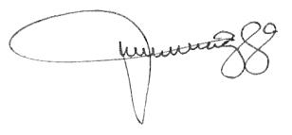  Bishop Feliciana P. Tenchavez  West Visayas Jurisdictional Area | 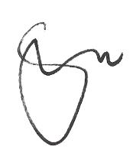  Bishop Ligaya F. San Francisco  West Mindanao Jurisdictional Area
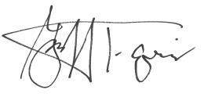

Bishop Hamuel G. Tequis
South East Mindanao Jurisdictional Area
Bishops Emeritus
Bishop Arturo R. Asi Bishop Roel P. Mendoza
Bishop Constante D. Claro Bishop Anacleto G. Serafica
Bishop Ebenezer C. Camino, Sr. Bishop Elorde M. Sambat
Bishop Erme R. Camba Bishop Dulce Pia-Rose
Bishop Gabriel A. Garol Bishop Jessie S. Suarez
Bishop Hilario M. Gomez, Jr. Bishop Rizalino Q. Taganas
Bishop Isaias L. Bingtan Bishop Eliezer M. Pascua
Bishop Jezer E. Bertoldo Bishop Jaime R. Moriles
Bishop Marino I. Inong Bishop Modesto D. Villasanta
Bishop Reuel Norman O. Marigza

